Chapter 5, Solution 65

Find v_{o} in the op amp circuit of Fig. 5.92.
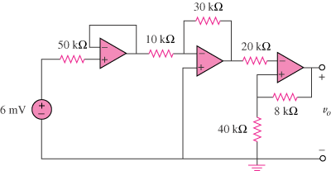
+
–

Figure 5.92
For Prob. 5.65.

Solution

The output of the first op amp (to the left) is 6 mV. The second op amp is an inverter so that its output is

The third op amp is a noninverter so that

